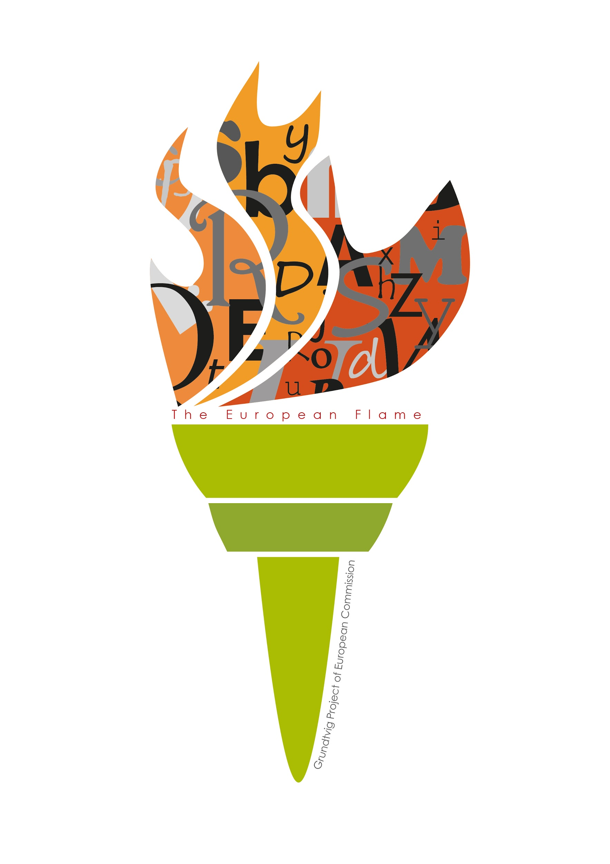
The European Flame: survey of labeled tools organized per language

Click on the name of the tool or activity to go to the corresponding google folder with more information.
Tech tip: you will need to log into your google account to open the google folders.
Tech tip 2: use ‘search’ and type your desired language to go to the language specific tools

N° | Tool/Activity | Country | Languages | Level | Purpose | Format | Feedback | Input | Decision | Costs | Interaction
 | Anki | Belgium | Language independent | All levels | Discover the meaning, consolidate | Digital online, digital offline | Yes, on exercise | Needed | Needed | Free | Not possible
 | Memrise | Belgium | Language independent | All levels | All levels of purpose | Digital online | Yes, on exercise | Possible | Possible | Free and paid version | Possible
 | Free puzzlemaker | Belgium | Language independent | All levels | Discover, integrate, consolidate | Digital online, non-digital | No | Needed | Not possible | Free version | Possible
 | Wordle | Belgium | Language independent | All levels | Consolidate | Digital online and offline | No | Needed | Needed | Free version | Possible
 | Byki | Iceland | Language independent | All levels | Meet new words  Exercise new word  Use words | Digital online and offline | Yes, on exercise  and progress | Possible | Possible | Free and paid version | Possible
 | Tungumála-  torg | Iceland | Language independent | All levels | Meet new words  Exercise new words  Use words | Digital online  Digital offline  Non-digital | Yes, on progress  and exercise | Possible | Not possible | Free version | Not possible
 | Hand computer | NL | Language independent | All levels | Exercise new words | Non-digital | Yes, on exercise  Yes, on progress | Needed | Not possible | Free version | Not possible
 | Story Cubes | NL | Language independent | All levels | use words | Non digital (‘cubes’) | No | Needed | Possible | Paid version | Possible
 | Voowl.pl | Poland | Language independent/English | All levels | Meet new words  Exercise new word  Use words  Create and upload own lists of selected language | Digital online/  Android | No | Possible | Possible | Free version | Not possible
 | Slowka-online.pl | Poland | Language independent | All levels | Meet/choose new words  Master/use  words | Digital online | Yes, on exercise | Needed | Needed | Free version | Possibile
 | iVocabulary 3 | Poland | Language independent | All levels | Meet/choose new words  Integrate (new) words  Consolidate words | Digital online | Yes, on exercise  Yes, on progress | Possible | Possible | Paid version | Not possible
2 | Duolingo | Belgium | More than 10 languages | All levels | All levels of purpose | Digital online | Yes, on exercise and on progress | Not possible | Not possible | Free | Possible
 | Lingro.com | Iceland | More than 10 languages | All levels | Meet new words  Exercise new words | Digital online | No | Not possible | Possible | Free version | possible
25 | 50languages | Sweden | More than 10 languages | Beginner  Intermediate  Advanced | Meet new words  Exercise new words | Digital offline | No | Not possible | Needed | Free and paid version | Not possible
33 | Funeasylearn.com | Poland | More than 10 languages | All levels | All levels of purpose | Digital online  Digital offline | No | Not possible | Not possible | Free version | Not possible
37 | Fiszki.pl | Poland | More than 10 languages | All levels | Meet/ choose  new words  Discover the meaning/ form | Non digital  Digital online | Yes, on progress | Non possible | Possible | Paid version only | Not possible
10 | Lyrics  Training | Belgium | Less than 10 languages | All levels | All levels of purpose | Digital online | Yes, on exercise | Not possible | Possible | Free version | Not possible
16 | Mindsnacks | Iceland | Less than 10 languages | All levels | Meet new words  Exercise new words  Use words | Digital offline | Yes, on progress | Not possible | Possible | Free and paid version | Possible
34 | Brainscape.com | Poland | English, French, Spanish, Chinese,  Latin,  German (verbs only),  Italian (verbs only), Portuguese (verbs only) | Beginner  lntermediate | Meet new words, discover the meaning, consolidate | Digital online | Yes, on exercise | Possible | Not possible | Free and paid version | Possible
14 | Lexipedia.com | Iceland | English  German  French  Dutch  Italian  Spanish | All levels | Meet new words | Digital online | Yes, on exercise  and progress | Needed | Needed | Free version | Not possible
38 | Learninvisible.com | Poland | English,  Spanish,  German,  French,  Italian,  Finnish | Beginner | Meet/choose new words  Discover the meaning/ form | Digital online/Apples only | Yes, on exercise | Not possible |  | Free and paid version | Not possible
27 | DigLin | Austria | German, Dutch, Finnish, English | Beginner | Meet new words  Discover the meaning / form | Digital online | Yes, on exercise | Not possible | Possible | Free version | Not possible
32 | Speeq.pl | Poland | English, German, Spanish, Polish | All levels | All levels of purpose | Digital online (Apps) | Yes, on progress | Possible | Possible | Paid version | Not possible
35 | Wkarteczkach.pl | Poland | English, German, French, Spanish | All levels | Meet/choose new words  Master/use  words | Non digital | Non | Not possible | Needed | Paide version | Not possible
36 | Fiszkiplus.pl | Poland | English, German, French, Spanish | All levels | Meet/choose new words  Master/use  Words  Discover the meaning/ form | Digital online  non digital | Yes, on progress | Possible | Possible | Paid version  only | Not possible
3 | Elke dag… | Belgium | French  Italian  Spanish | Beginner | Meet new words, discover the meaning | Digital offline | Yes, on exercise and on progress | Not possible | Possible | Free and paid version | Not possible
22 | Taboo | NL | English  German  Dutch | Advanced | Use words | Non-digital | No | Not possible | Possible | Paid version only | Needed
4 | English Club | Belgium | English | Intermediate  advanced | All levels of purpose | Digital online, digital offline | Yes, on exercise | Not possible | Possible | Free and paid version | Possible
5 | Learn English | Belgium | English | Advanced | All levels of purpose | Digital online and offline | Yes, on exercise | Not possible | Possible | Free | Possible
6 | Learning English for adult learners | Belgium | English | Beginner  intermediate | All levels of purpose | Digital offline | No | Not possible | Possible | Free | Not possible
17 | PowerVocab Word Game | Iceland | English | All levels | Meet new words  Exercise new words  Use words | Digital offline | Yes, on progress | Not possible | Possible | Free and paid version | Possible
19 | Vocabulary.co.il | Iceland | English | Beginner  Intermediate | Meet new words  Exercise new words  Use words | Digital online | Yes, on progress  and exercise | Not possible | Possible | Free version  and paid version | Possible
26 | Bitsboard | Sweden | English | Beginner  Intermediate | Meet new words  Exercise new words | Digital offline | Yes, on exercise | Possible | Needed | Free and paid version | Possible
28 | Vocabulary.com | Austria | English | All levels | Meet new words  Discover the meaning / form  Integrate (new) words  Consolidate words  Master/use words | Digital online | Yes, on exercise  Yes, on progress | Possible | Possible | Free version | Possible
30 | Vocabulary.com | Poland | English | Advanced | All levels of purpose | Digital online | Yes, on  exercise  Yes, on  progress | Possible | Possible | Free (computer) Paid  (mobile) | Possible
20 | NT2 Nieuwslezer | NL | Dutch | All levels | Meet new words  Exercise new words | Digital online | Yes, on progress  and exercise | Not possible | Possible | Paid version only | Not possible
23 | Wrts | NL | Dutch | Beginner  Intermediate  Advanced | Exercise new words | Digital online | Yes, on exercise | Needed | Not possible | Free version | Possible
8 | Spanish Challenge | Belgium | Spanish | All levels | Discover, integrate, consolidate | Digital online | Yes, on exercise and on progress | Not possible | Possible | Free and paid version | Needed
11 | Matdid | Belgium | Italian | All levels | All levels of purpose | Digital online | Yes, on exercise | Not possible | Needed | Free version | Not possible

